Module 3 – MBSA Lab

1. Run MBSA Application

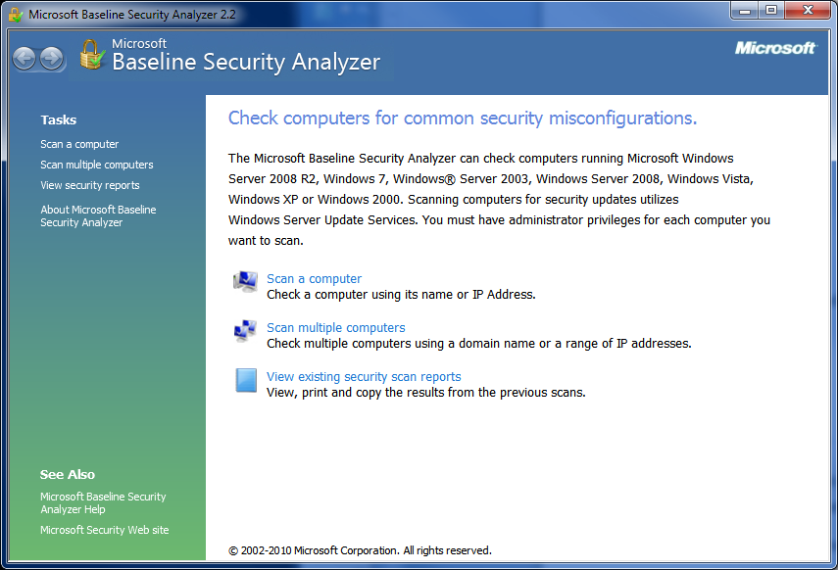

1. Although MBSA can be used to scan a range of computers on a network, select *Scan a computer*, for your individual system.
2. Highlight the top 5 options

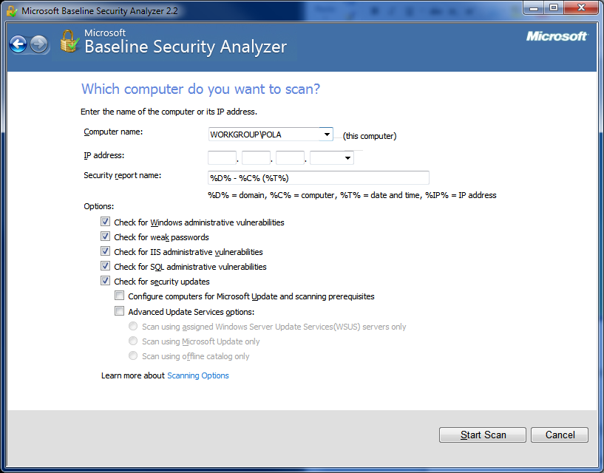

1. Select *Start Scan*
2. Review the results, by scrolling down the results
   * Click on *Result Details* for more information
   * For issues, select on *How to Correct this*

